TIMBER CITY ADVENTURE RACE

Registration opens at 7 AM at Canton. Race starts at 7:30 AM at Canton. Rec class starts first. Race ends at the Decker Hotel, downtown Maquoketa. You must provide your own equipment (bike, helmets, paddles [no double bladed with canoes], life jackets, canoe, etc.) If canoe, life jacket and paddles are needed, send an extra $25 ASAP as canoe rental is limited.

TEAM COMPETITION
2 PERSON TEAM: Consists of 2 members who do all legs of the race. Finish time is average of both members times
4 PERSON TEAM: Relay style. Must have 2 women, 2 men for mixed class.

You cannot do both individual and team competitions.

RECREATION DIVISION
Individual: Male/Female
2 person team: Men/Women/Mixed
4 person team: Men/Women/Mixed
Age Brackets:
34 & below, 35-49, 50+
2 person team (average age)
4 person relay: Men/Women/Mixed (All Ages)

SPECIAL DIVISION – RACING
No age classes.
DIVISIONS: (same as Recreation Class) Individual, 2 person team, 4 person relay teams
Cash prizes:
Individual 1st Place $50 2nd Place $25
2/4 Person Team 1st Place $80 2nd Place $40
Cash Prizes – racing division only.

AWARDS
Top two teams in each category (Male, Female, Mixed)

THE RACE

The Canoe… is an 8 mi. course on the Maquoketa River beginning at Canton. You will wind below towering limestone bluffs and through secluded valleys on scenic route to Royertown Bridge access. This is the 2nd bridge you will come to. Exit on left side, carry canoe past clear zone, run up drive to get bike or tag biker if on relay team. In transition area, biker must be stationary at time of tag. No double-bladed paddles allowed with canoes.

(Rec. canoes must be 18 feet or less in length and/or weigh over 50 pounds)

The Bike… A 14 mile course that starts with a challenging incline – one of the steepest in Jackson Country, continues with several rolling hills, a steep decline with sharp right turn at the bottom and long flats to gather speed. Biker must follow all traffic laws, including stop at Highway 61 before crossing. Runner can start with no hand tag.

(No drafting allowed)

The Run… is a 5K (3.1 mile) mostly flat course starting at Hurstville. Head south on old Highway 61, straight into Maquoketa, turn right for run route along river, loop back to Main Street, and finish at the Decker Hotel.

Water will be available at each exchange (and on run course). Volunteers will be stationed throughout the course.

Showers available at Maquoketa Public Swimming Pool. Towels will not be provided.

Additional entry forms at
www.maquoketachamber.com

ENTRY FORM

(CIRCLE ONE:)
Individual
2 Person Team: Mixed Men Women
4 Person Team: Mixed Men Women
(CIRCLE ONE:)
Division: Racing Recreation

Individual/1st Canoeist
Name_____________________________ M/F ____
Age______ Address__________________________
City ______________________State/Zip ________
Phone_______________ Shirt (circle one) M L XL
E-mail: ____________________________________
2nd Canoeist (if applicable)
Name_____________________________ M/F ____
Age______ Address__________________________
City ______________________State/Zip ________
Phone_______________ Shirt (circle one) M L XL
E-mail: ____________________________________

Biker
Name_____________________________ M/F ____
Age______ Address__________________________
City ______________________State/Zip ________
Phone_______________ Shirt (circle one) M L XL
E-mail: ____________________________________

Runner
Name_____________________________ M/F ____
Age______ Address__________________________
City ______________________State/Zip ________
Phone_______________ Shirt (circle one) M L XL
E-mail: ____________________________________

FEES: Individual $30/2 person $50/4 person relay $80
Canoe Rental Yes / No (If yes, add $25 rental fee)
Make checks payable to Maquoketa Chamber

FREE T-SHIRT IF REGISTERED BY JUNE 10TH!

I understand that I (and my teammates) will be required to sign an additional acknowledgement-liability release form when I register.
Signature__________________________Date_______
(Individual participant/team captain)

Post – Race Activities
Post-race celebration at the Decker Hotel – 11:30 AM

Race Day Schedule

Drop off gear at exchanges 6:15 AM
Registration at Canton opens 7:00 AM
Pre-race Briefing 7:20 AM
Rec. canoe wave begins 7:30 AM
Racing canoe wave 8:00 AM
Post-race celebration 11:30 AM
Awards Ceremony 12:30 AM

Transportation provided back to vehicle after finish.

Lodging: Comfort Inn, Decker Hotel, Super 8, Squiers Manor Bed & Breakfast, Whispering Meadows Resort
Camping: Horseshoe Pond, Maquoketa Caves State Park, Eden Valley

Sponsors:
Gold Sponsors:
Alliance Pipeline; Maquoketa Area Chamber of Commerce; Maquoketa State Bank; Nissen-Caven Insurance and Real Estate; Smiles On Main

Silver Sponsors:
Culligan of Maquoketa; Family Dollar Services, Inc.; Sybesma’s Eye & Vision Center

Bronze Sponsors:
A-DAC Plastics Corporation; Brian Aunan, CPA; Family Pharmacy; Gasser True Value; Gary Starr Painting & Decorating; Theisen’s Family Farm & Home Show; Timber City Trophy & Shirt Works

Other:
B & C Liquor; Decker Hotel & Restaurant; Fareway Stores, Inc. of Maquoketa; Maquoketa Bottling Works; Moritz Signs; River City Bike Shop

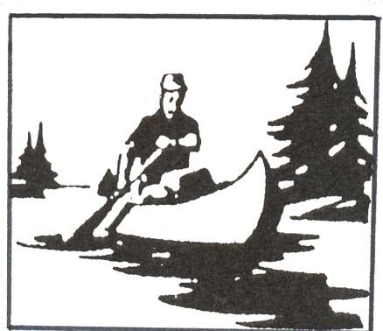

Maquoketa Chamber Presents…

^{6th} Annual
Timber City
Adventure Race

Saturday,

June 25, 2005
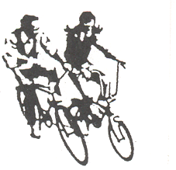
Start: 7:30 AM at
Canton, Iowa
Finish at The Decker Hotel

Downtown, Maquoketa, Iowa

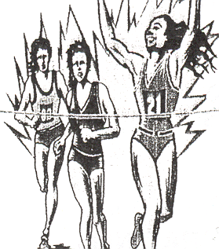

Order of Race:

Canoe 8 miles / Bike 14 miles / Run 5 K

